Infix, prefix, postfix
Link:infix,prefix,postfix

Consider another infix example, A + B * C. The operators + and * still appear between the operands, but there is a problem. Which operands do they work on? Does the + work on A and B or does the * take and C? The expression seems ambiguous.
Although all this may be obvious to you, remember that computers need to know exactly what operators to perform and in what order
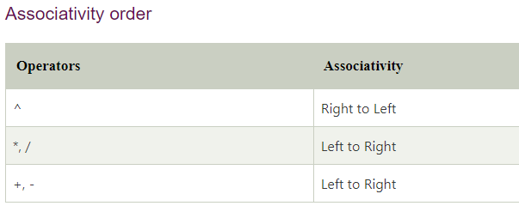

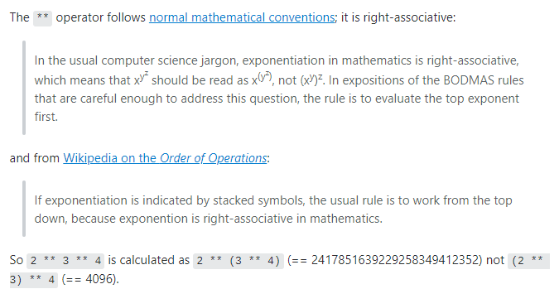

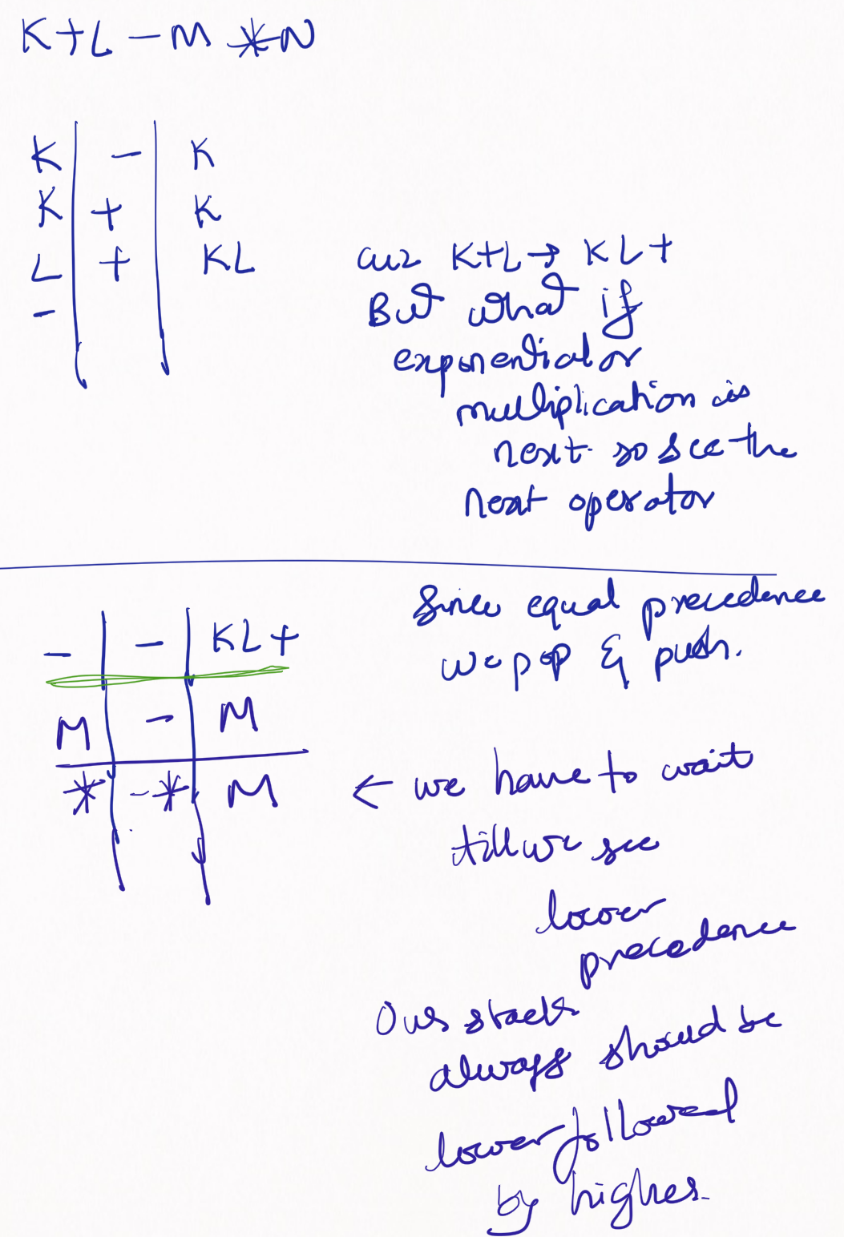

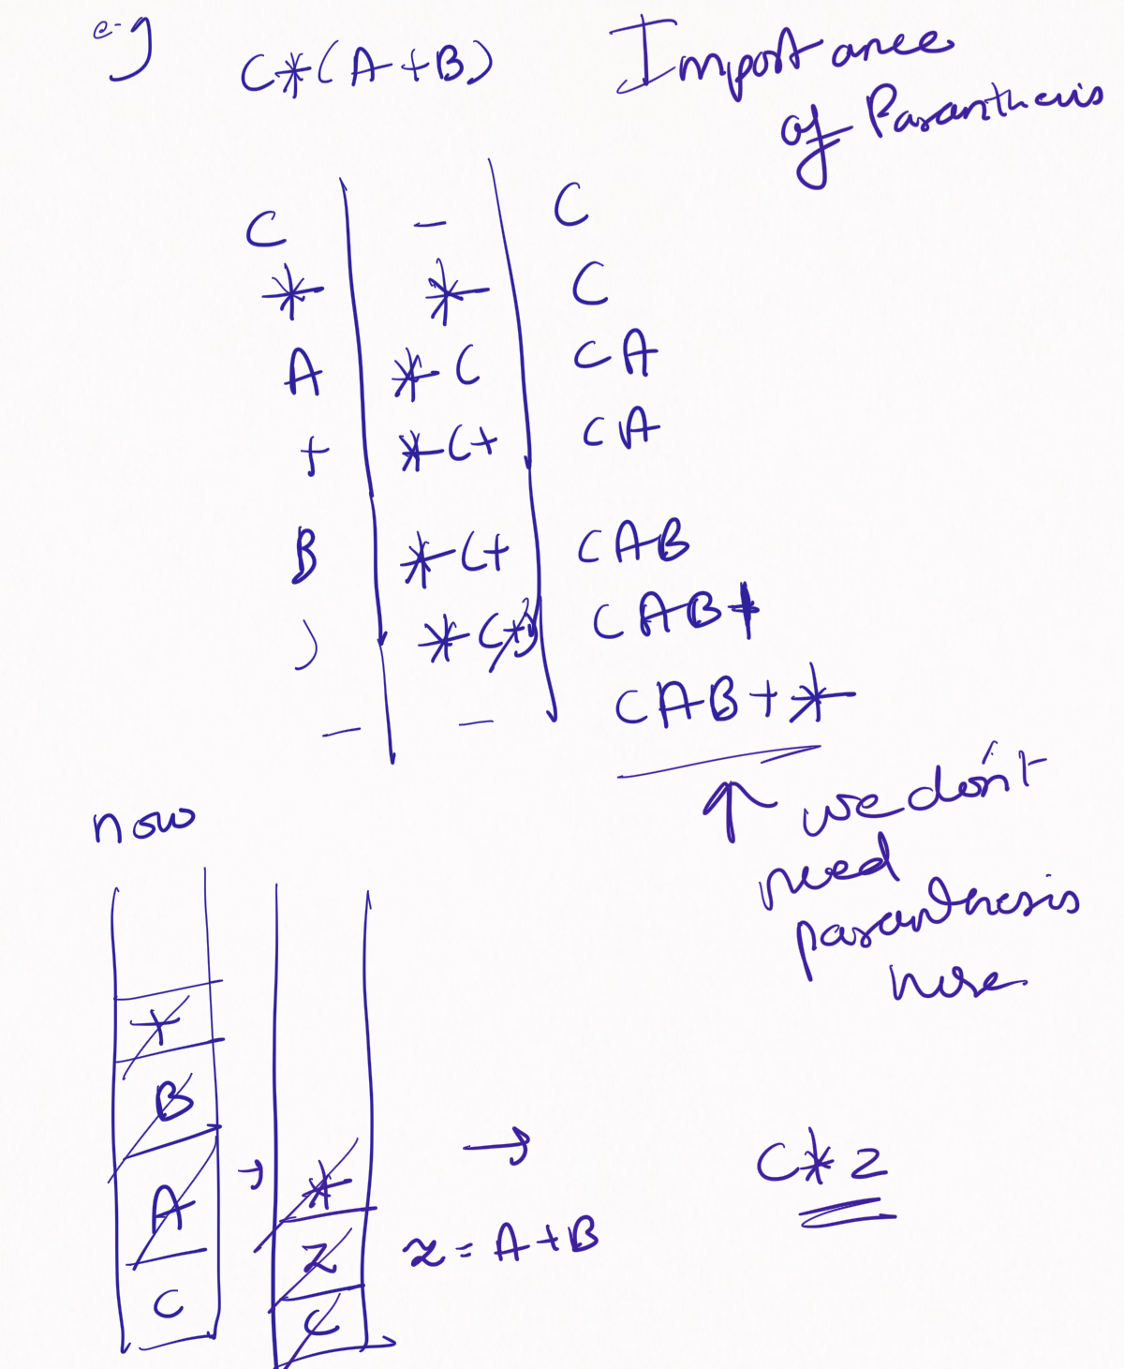

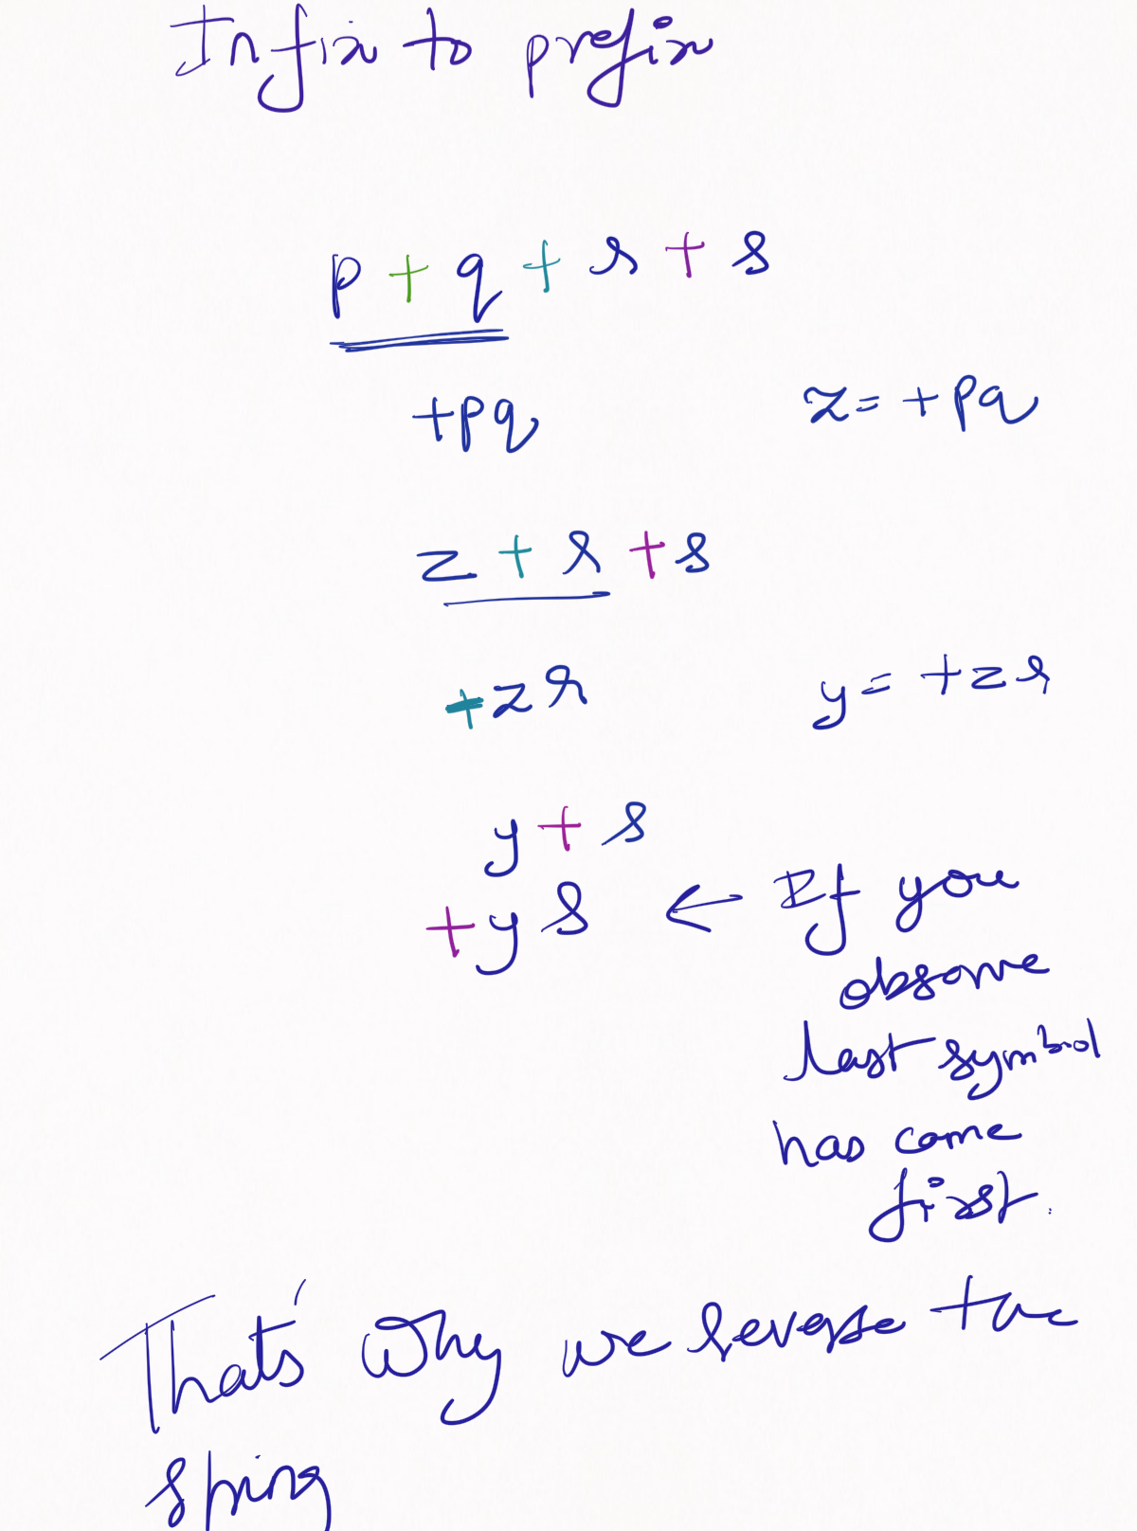

Here you push in the stack when equal and greater.
Also less precedence followed by higher precedence or equal precedence.
